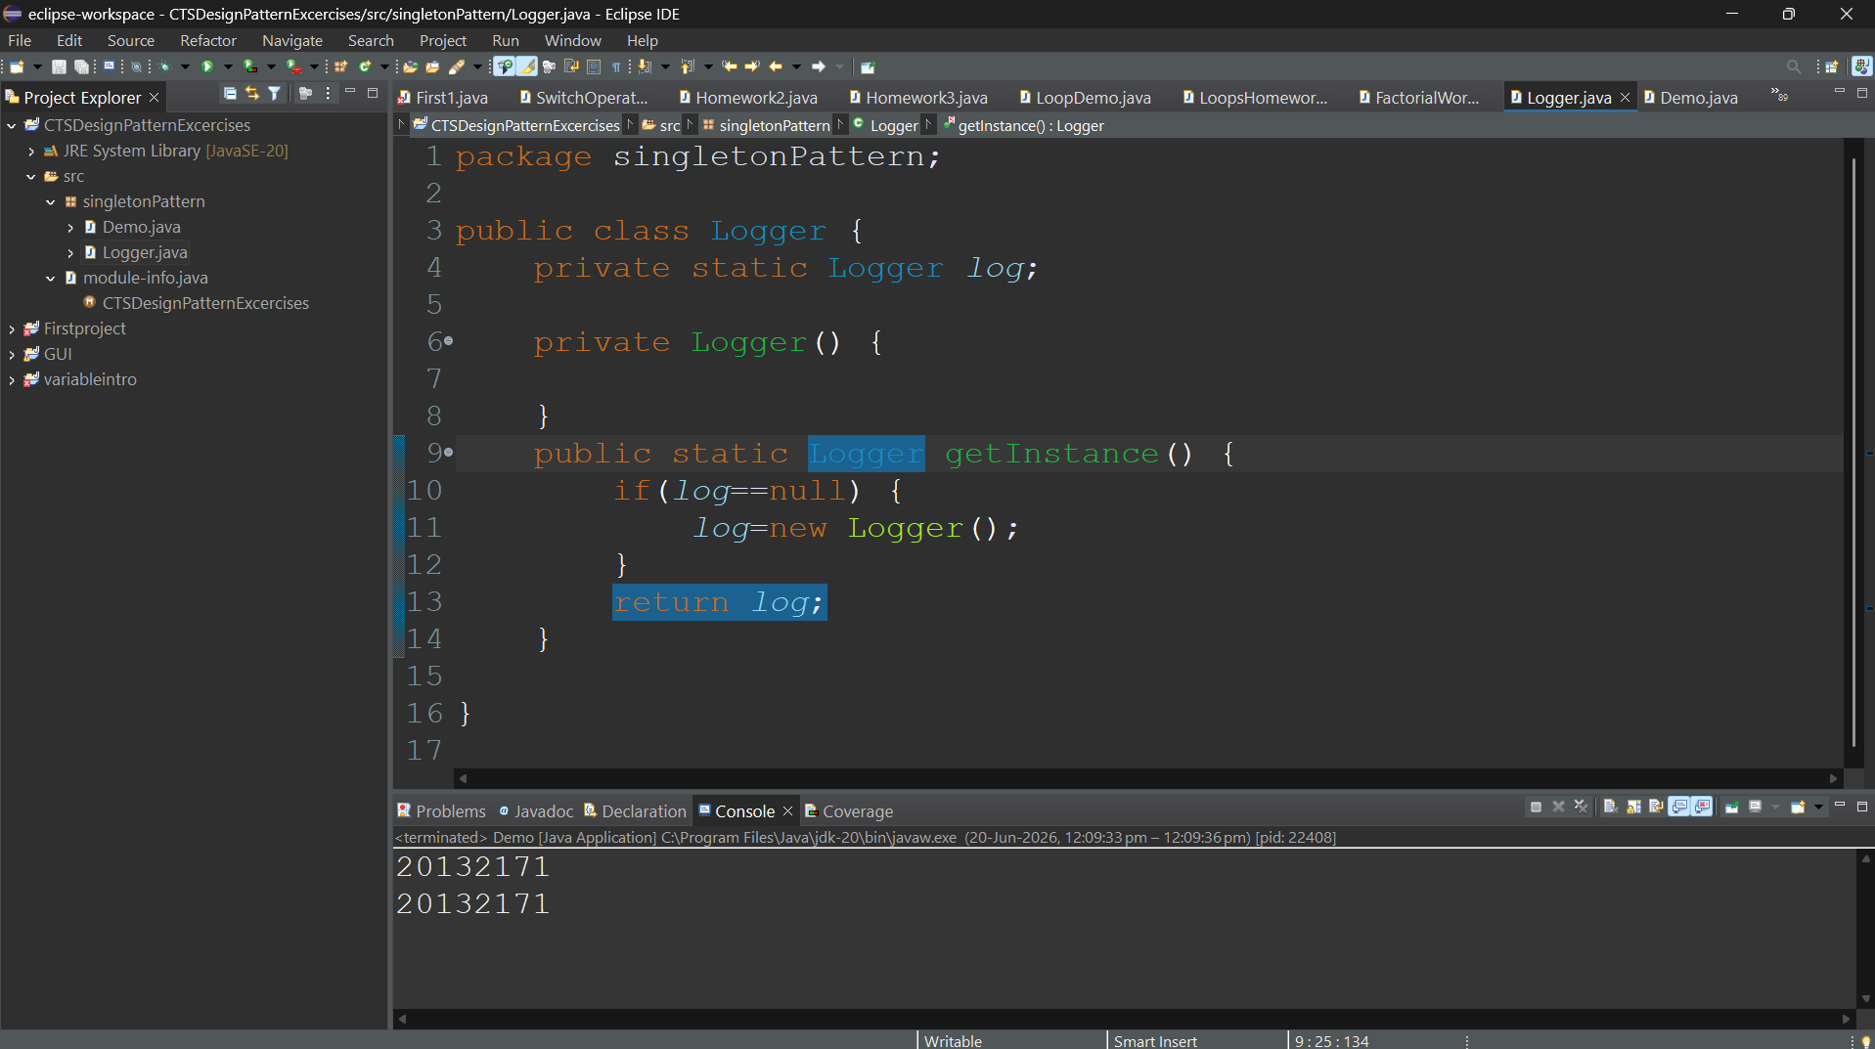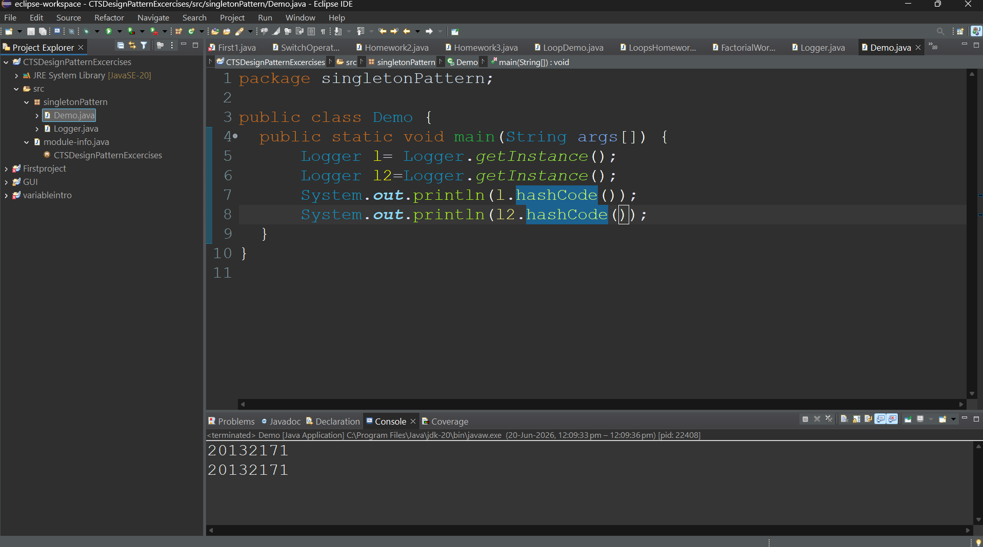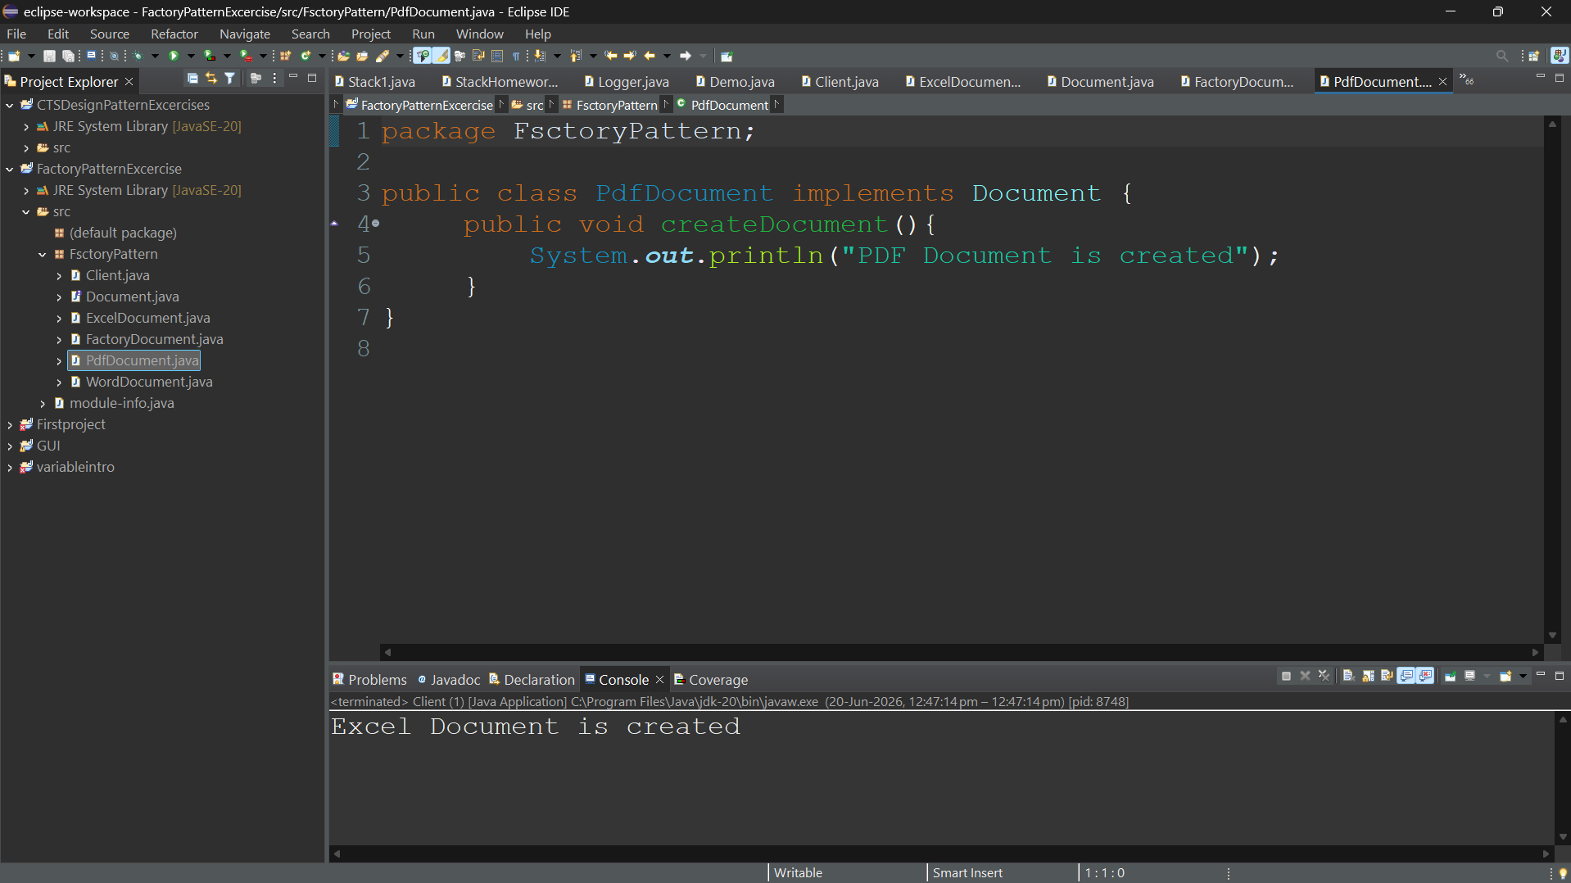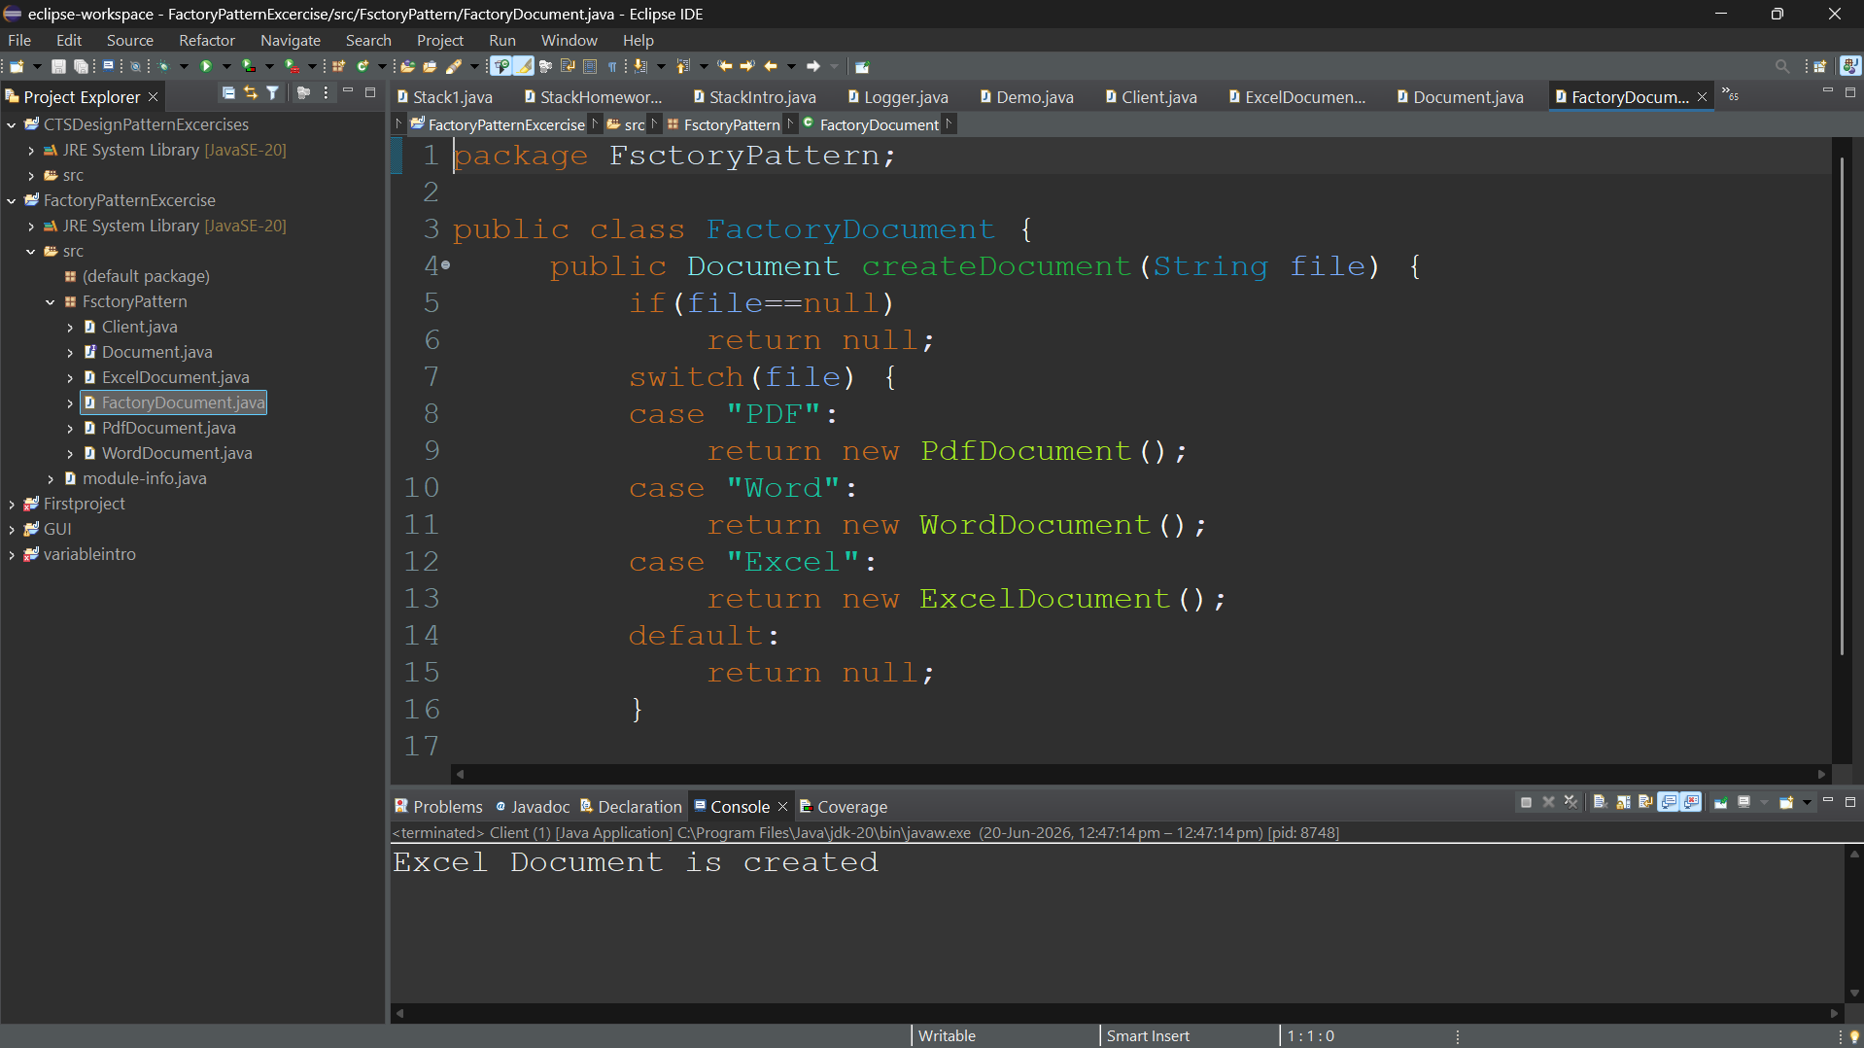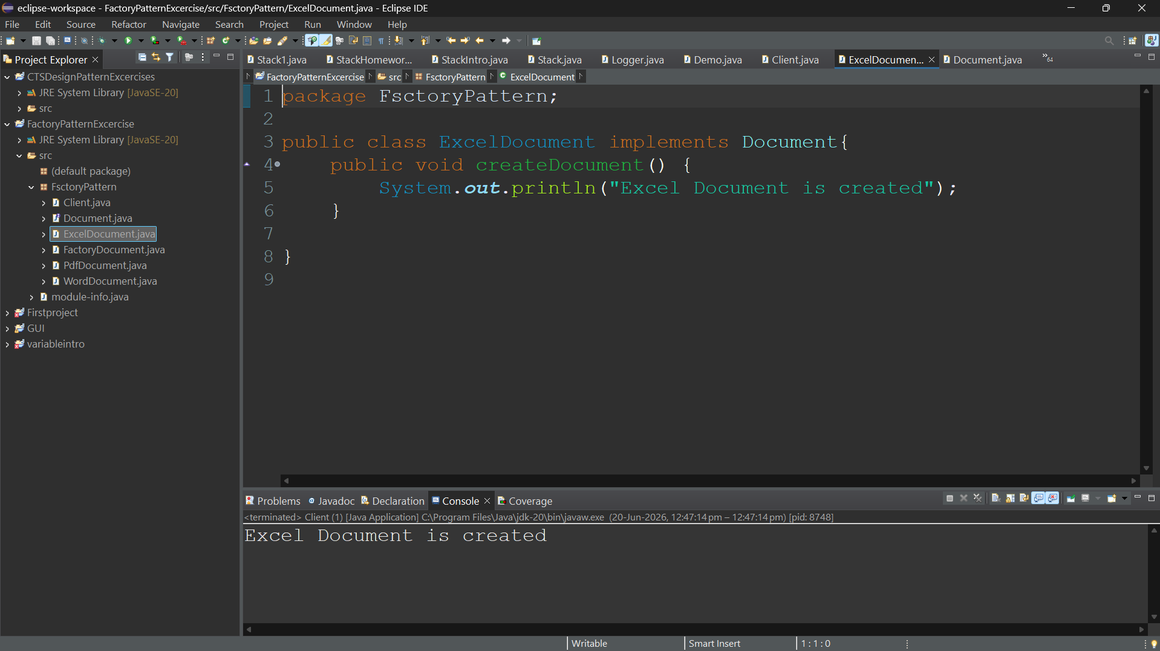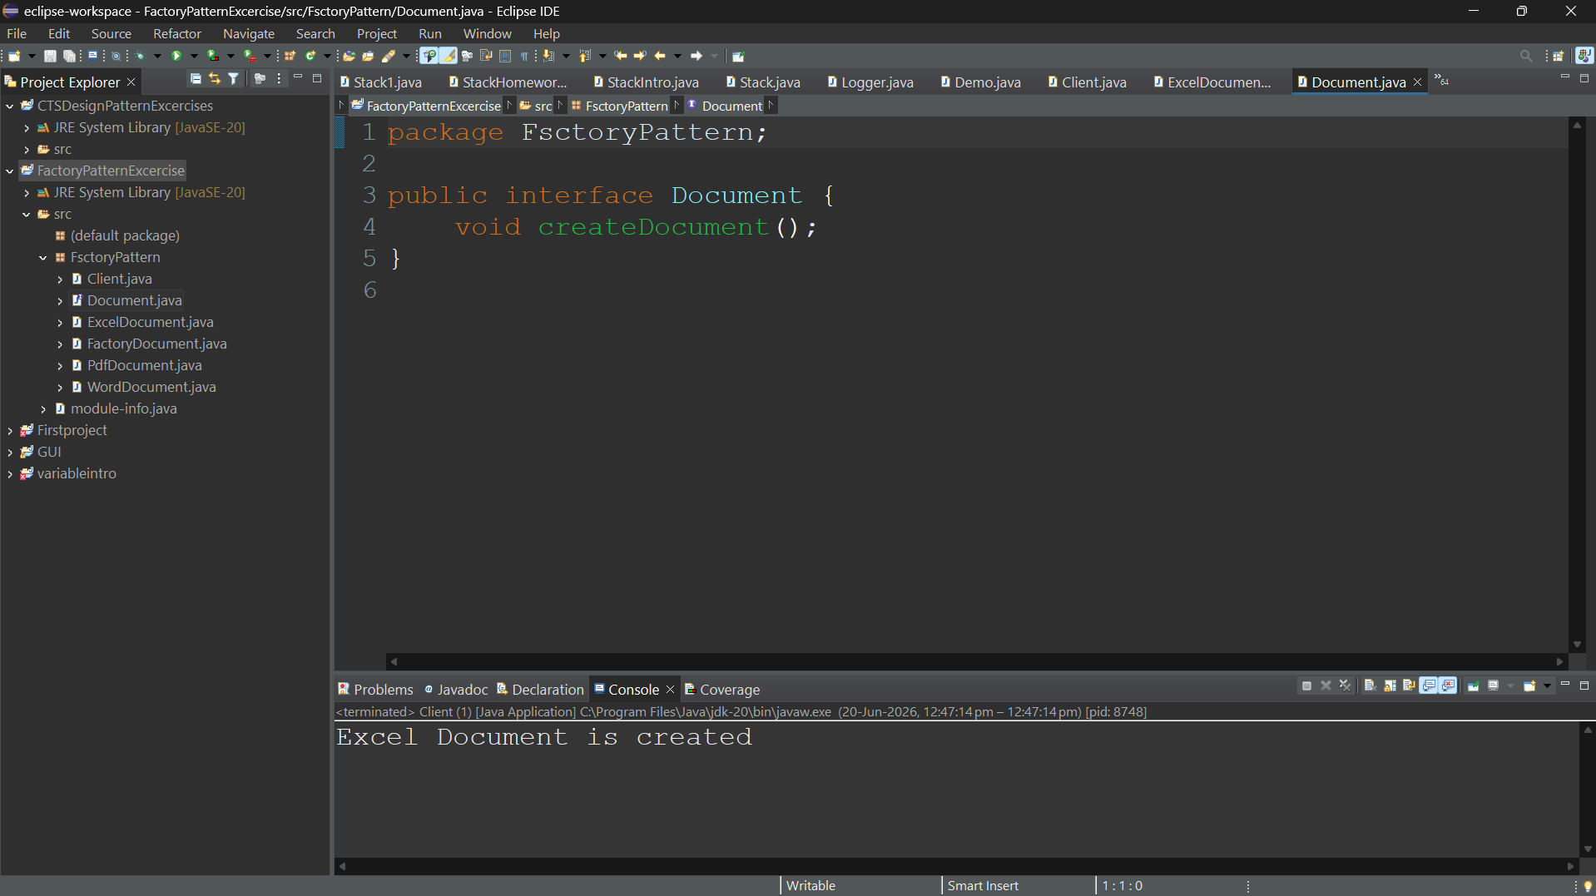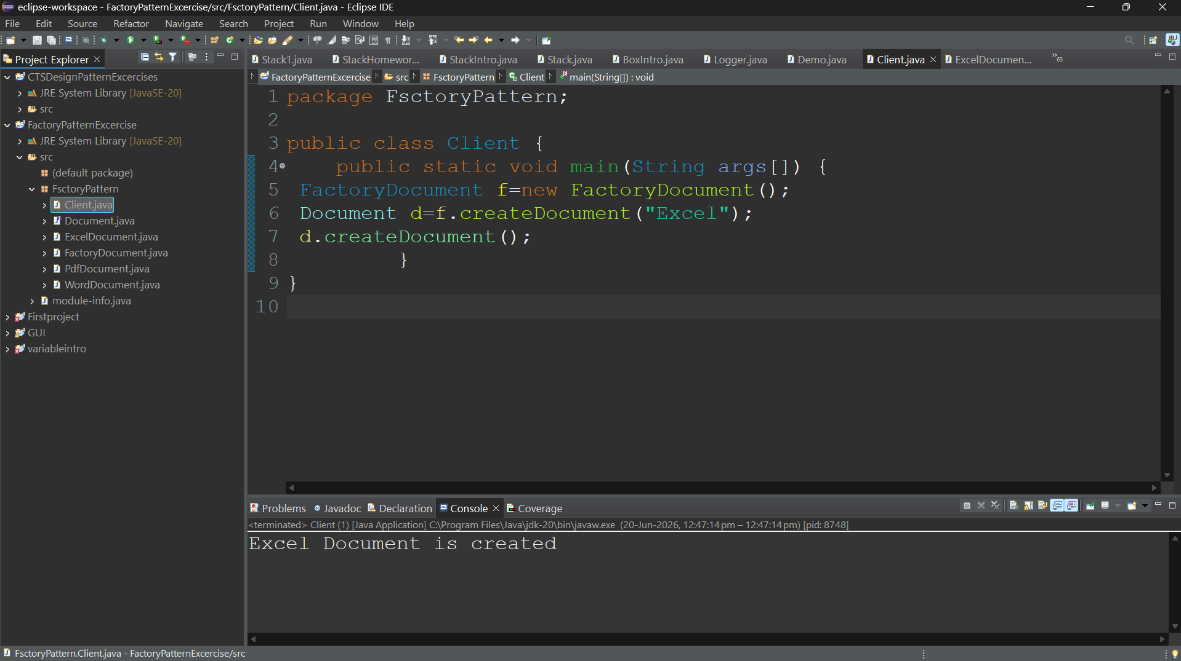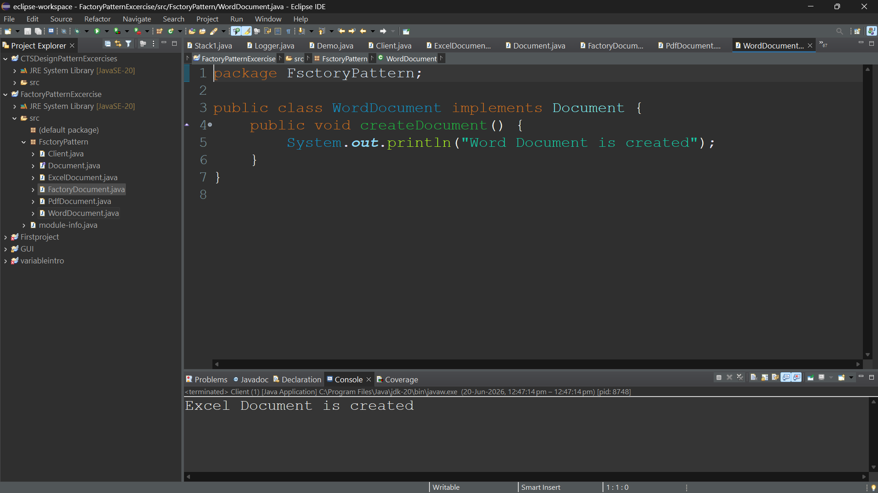

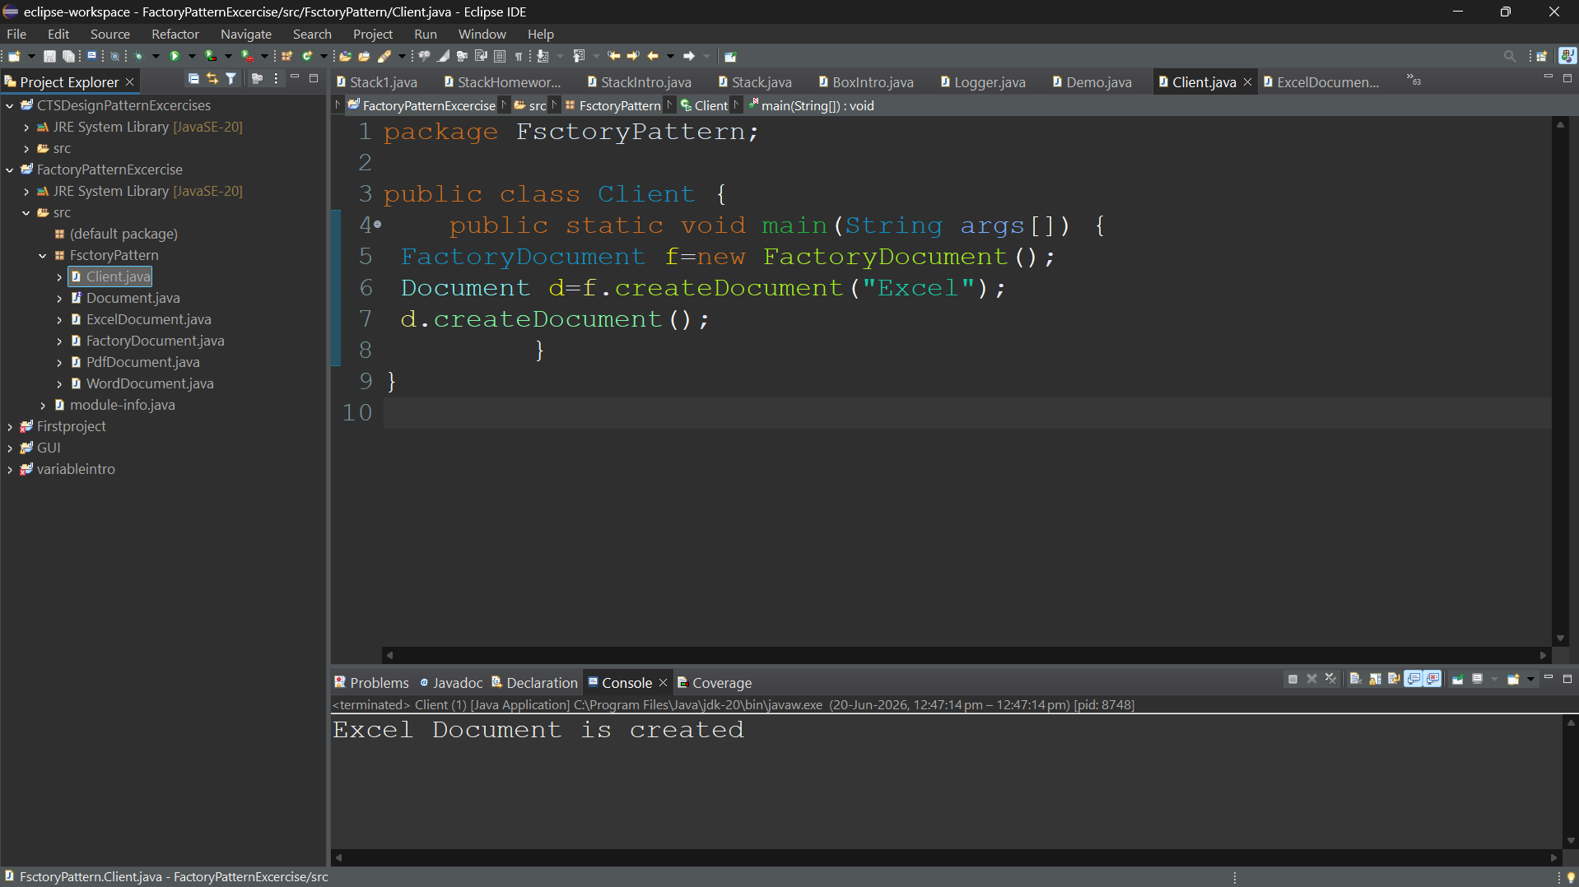

Exercise 3 - Builder Pattern
Computer.java
public class Computer{
private String cpu,ram,storage;
private Computer(Builder b){
cpu=b.cpu; ram=b.ram; storage=b.storage;
}
public void display(){
System.out.println(cpu+" "+ram+" "+storage);
}
public static class Builder{
private String cpu,ram,storage;
public Builder setCPU(String cpu){
this.cpu=cpu; return this;
}
public Builder setRAM(String ram){
this.ram=ram; return this;
}
public Builder setStorage(String storage){
this.storage=storage; return this;
}
public Computer build(){
return new Computer(this);
}
}
}
BuilderTest.java
public class BuilderTest{
public static void main(String[] args){
Computer c=new Computer.Builder()
.setCPU("i7").setRAM("16GB").setStorage("512GB").build();
c.display();
}
}

EXERCISE 4: ADAPTER PATTERN
PaymentProcessor.java
public interface PaymentProcessor {
void processPayment(double amount);
}
PayPalGateway.java
public class PayPalGateway {
public void makePayment(double amount){
System.out.println("PayPal Payment: " + amount);
}
}
StripeGateway.java
public class StripeGateway {
public void charge(double amount){
System.out.println("Stripe Payment: " + amount);
}
}
PayPalAdapter.java
public class PayPalAdapter implements PaymentProcessor{
private PayPalGateway gateway = new PayPalGateway();
public void processPayment(double amount){
gateway.makePayment(amount);
}
}
StripeAdapter.java
public class StripeAdapter implements PaymentProcessor{
private StripeGateway gateway = new StripeGateway();
public void processPayment(double amount){
gateway.charge(amount);
}
}
AdapterTest.java
public class AdapterTest {
public static void main(String[] args){
PaymentProcessor p = new PayPalAdapter();
p.processPayment(1000);
}
}

Exercise 5 - Decorator Pattern
Notifier.java
public interface Notifier{ void send(); }
EmailNotifier.java
public class EmailNotifier implements Notifier{
public void send(){ System.out.println("Email Sent"); }
}
NotifierDecorator.java
public abstract class NotifierDecorator implements Notifier{
protected Notifier notifier;
public NotifierDecorator(Notifier n){ notifier=n; }
}
SMSNotifierDecorator.java
public class SMSNotifierDecorator extends NotifierDecorator{
public SMSNotifierDecorator(Notifier n){ super(n); }
public void send(){ notifier.send(); System.out.println("SMS Sent"); }
}
DecoratorTest.java
public class DecoratorTest{
public static void main(String[] args){
Notifier n=new SMSNotifierDecorator(new EmailNotifier());
n.send();
}
}
Exercise 6 - Proxy Pattern
interface Image{ void display(); }
class RealImage implements Image{
private String file;
public RealImage(String file){ this.file=file; }
public void display(){ System.out.println("Displaying "+file); }
}
class ProxyImage implements Image{
private RealImage realImage;
private String file;
public ProxyImage(String file){ this.file=file; }
public void display(){
if(realImage==null) realImage=new RealImage(file);
realImage.display();
}
}
class ProxyTest{
public static void main(String[] args){
Image img=new ProxyImage("sample.jpg");
img.display();
}
}
Exercise 7 - Observer Pattern
import java.util.*;
interface Observer{ void update(double price); }
class MobileApp implements Observer{
public void update(double price){ System.out.println("Mobile:"+price); }
}
class WebApp implements Observer{
public void update(double price){ System.out.println("Web:"+price); }
}
class StockMarket{
List<Observer> observers=new ArrayList<>();
void register(Observer o){ observers.add(o); }
void notifyObservers(double p){
for(Observer o:observers) o.update(p);
}
}
class ObserverTest{
public static void main(String[] args){
StockMarket s=new StockMarket();
s.register(new MobileApp());
s.register(new WebApp());
s.notifyObservers(500);
}
}
Exercise 8 - Strategy Pattern
interface PaymentStrategy{ void pay(int amount); }
class CreditCardPayment implements PaymentStrategy{
public void pay(int amount){ System.out.println("Card:"+amount); }
}
class PayPalPayment implements PaymentStrategy{
public void pay(int amount){ System.out.println("PayPal:"+amount); }
}
class PaymentContext{
private PaymentStrategy strategy;
public PaymentContext(PaymentStrategy s){ strategy=s; }
void execute(int amount){ strategy.pay(amount); }
}
class StrategyTest{
public static void main(String[] args){
new PaymentContext(new CreditCardPayment()).execute(1000);
}
}
Exercise 9 - Command Pattern
interface Command{ void execute(); }
class Light{
void on(){ System.out.println("Light ON"); }
void off(){ System.out.println("Light OFF"); }
}
class LightOnCommand implements Command{
private Light light;
LightOnCommand(Light l){ light=l; }
public void execute(){ light.on(); }
}
class RemoteControl{
private Command command;
RemoteControl(Command c){ command=c; }
void pressButton(){ command.execute(); }
}
class CommandTest{
public static void main(String[] args){
Light l=new Light();
RemoteControl r=new RemoteControl(new LightOnCommand(l));
r.pressButton();
}
}
Exercise 10 - MVC Pattern
class Student{
private String name; private int id;
public Student(String n,int i){ name=n; id=i; }
public String getName(){ return name; }
public int getId(){ return id; }
}
class StudentView{
void display(Student s){
System.out.println(s.getName()+" "+s.getId());
}
}
class StudentController{
private Student model; private StudentView view;
StudentController(Student m,StudentView v){ model=m; view=v; }
void updateView(){ view.display(model); }
}
class MVCTest{
public static void main(String[] args){
Student s=new Student("John",101);
new StudentController(s,new StudentView()).updateView();
}
}
Exercise 11 - Dependency Injection
interface CustomerRepository{
String findCustomerById(int id);
}
class CustomerRepositoryImpl implements CustomerRepository{
public String findCustomerById(int id){
return "Customer "+id;
}
}
class CustomerService{
private CustomerRepository repo;
CustomerService(CustomerRepository repo){ this.repo=repo; }
void showCustomer(int id){
System.out.println(repo.findCustomerById(id));
}
}
class DependencyInjectionTest{
public static void main(String[] args){
CustomerRepository repo=new CustomerRepositoryImpl();
CustomerService service=new CustomerService(repo);
service.showCustomer(1);
}
}

